11.35: The area A in Eq.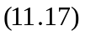 has increased by a factor of 9, so the shear strain for the larger object would be 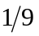 that of the smaller.

